Editorial

Greetings.

2016 is well under way and haven’t we, in Sydney at least, had the hottest of summers?

Since our last newsletter in October 2015, two significant events have occurred – well, significant to those of us descendant from Joshua Middleton Moxon, at any rate.

The first occurred on Christmas Day – the discovery of a whole new branch of our family. Look for the story by Pamella and her connections to our family (Miriam’s Miracle).

And the second was another reunion at Stuart Town in New South Wales. It was truly wonderful to meet a host of “new” cousins and to catch up with ones we have known for some time.

The ABC in Canberra posted to their website a long article on All Saints Church in Ainslie (a suburb of Canberra). It’s a church with Moxon connections, as you’ll read later.

Margaret, busy as usual, has unearthed more information on yet another convict, John Moxon, and has continued to work on the family trees.

Please stay in touch and encourage your family members to join us.

Regards for now.

John Bruce Moxon (MX27)
johnmoxon1@gmail.com
0412 539 110
Contents
Editorial 1
Correction 1
New Members 1
All Saints, Ainslie 1
James Moxham 2
Moxon Family feuds 3
Another Moxon Muster 4
Miriam’s Miracle 4
Access to Trees 6
About this Newsletter 6
New Members

- John Peter Moxon, Pitt Town, NSW (MX27);
- Paul S Moxon, Daroka, NSW (MX27)
- Raylee Wildie, Pacific Palms, NSW (MX27)
- Kaye Banes, Preston, Victoria (MX27)
- Denise Gai Clark, Orange, NSW (MX27)
- Leith Vernon, Raworth, NSW (MX27)
- Pamella Vernon, Surry Hills, NSW (MX27)
- Kenneth Ewing Moxham, Verbrae, SA

Correction to: “The Strange Tale of Alfred
Wilson/Moxon”

Alfred Wilson/Moxon’s story in the last edition of this newsletter contained an error – sadly repeated in a press release your editor issued a few weeks ago.

Alfred’s parents were named on his marriage certificate as “Alexander Wilson and Clara Ann Wilson, nee Riddle”, not “Ada Ann Wilson”, as reported.

The error is mine – I apologise profusely.

Editor

All Saints Church Ainslie

All Saints church in Ainslie, a suburb of Canberra, was not always a church.

Originally, it was the mortuary receiving railway station at the Necropolis at Haslem Creek (now Rookwood Cemetery).

Trains would leave the Mortuary Station at Redfern and take mourners and the deceased from Redfern to Haslem Creek.

The stations were opened in 1868, and ceased being used in 1939.

The Rookwood one fell into disrepair and was eventually bought for 100 pounds, dismantled, transported to Canberra and reassembled.

The Moxon connection is that both mortuary stations have ornate carvings and they were done by two stone carvers, one of whom was Joshua Middleton Moxon (MX27).
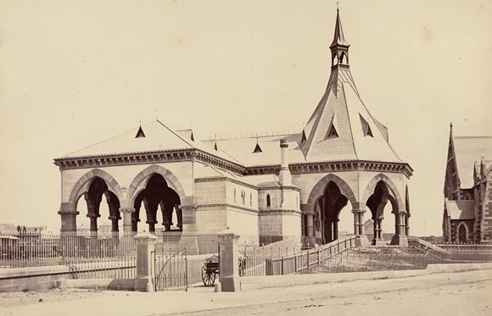
The Redfern station (above) is still standing but is currently not used at all.

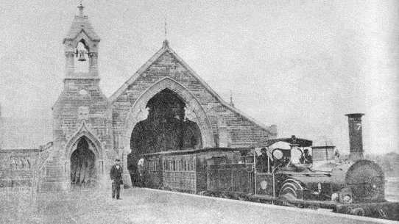
The carvings in the Ainslie church have particular significance, as the ABC reports: “There are seven pairs of columns (referring to days of the week), there are 52 separate arches (referring to weeks of the year), and there are 365 carvings (referring to days of the year).
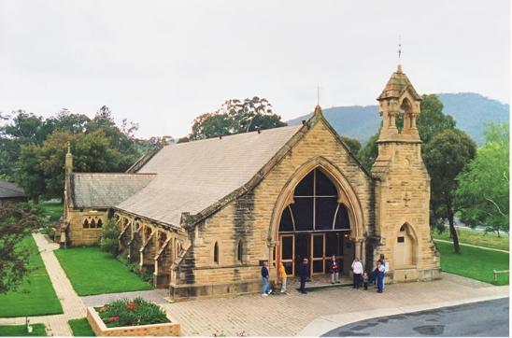
Each of the stone carvings is different, and most of them are of foliage which have special meanings.”
James Moxham
Convict
Born in 1794, James Moxham was a son – probably the oldest – of Thomas and Sarah Moxham of Birmingham, baptised on 20th July, 1795.

In 1813, James joined the Foot Guard during the Napoleonic Wars.

This Moxham family established themselves as gunsmiths and later, maltsters and were upwardly mobile in Birmingham throughout the 19thcentury.

James’ brother, Thomas (born 1804) was originally a gun stockman, then a gunsmith, and at his death was described as a gun manufacturer, leaving an estate of “less than £12,000” at his death in 1878. His son Thomas, a maltster was also wealthy, leaving just under the same amount.

However, in February 1819, James Moxham was convicted at the Northampton Assizes of uttering forged notes and transported to New South Wales for fourteen years. He arrived on the Prince Regent in early 1820 and was sent to Parramatta for distribution. At one stage he was located at Port Macquarie, but returned to Sydney well before obtaining his ticket of leave in 1831. He was given a certificate of Freedom in early 1833 when his sentence expired.

By 1826, James had requested and been approved to marry another convict Diana Hughes, also known as Mary Anne Rycroft, a dressmaker from London who was sentenced to transportation for life, arriving on the Midas in 1825.

By 1829, he was working for a Mr Jennings in Castlereagh Street, making shoes for children with misshapen feet, and gaining an excellent reputation for such work. When he gained his certificate of freedom, he set up in his former calling as a gunsmith.

There is no NSW record of any children being born to James Moxham and his wife Diana/Mary Anne. It would appear that James died in 1848 in the Goulburn area, aged 55.

Margaret Tucker Moxon
Moxon families were not always on good terms

It’s not always the case that family members see eye to eye, and nothing seems to inflame sentiment quite like politics (and maybe religion).

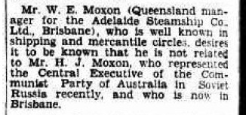
And sometimes, it’s not even a family member who upsets people, just someone with the same surname.

The editor’s father, Herbert (Bert) John Moxon (1902-1987), was a member of the Communist Party of Australia from at least 1921 until 1932 (when he was expelled).

A brief outline of his life was published in this newsletter in 20??

Here is how he is described in the book “Our Unswerving Loyalty
A documentary survey of relations
between the Communist Party of Australia and Moscow, 1920–1940
David W. Lovell and Kevin Windle
(editors)”
Moxon, Herbert: an organizer for the CPA in Queensland in the 1920s, a member of the Party’s CC, and a key player in the dramatic change of Party leadership in 1929. Moxon became Party secretary at the Ninth Conference, and proceeded to implement the Third Period line and expel a number of former leaders; he was relieved of his duties by Moore at the end of 1930, and was ultimately expelled early in 1932.

Two items in the press of the time illustrate how sometimes when we fall out of favour people differ in their responses.

In April 1928, Bert was sent to Russia to attend a meeting of the Central Committee to report on how things were going in Australia.

On his return, this notice appeared in the Brisbane Courier on 24 July 1928.

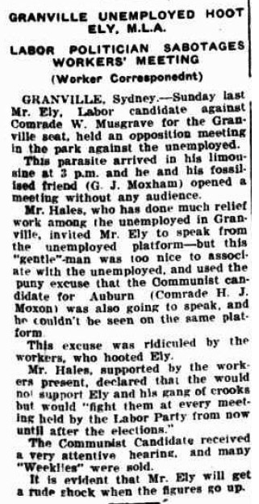
And in 1930, when Bert was the CPA candidate for the seat of Auburn in Sydney, the Workers Weekly (the Communist newspaper) reported on an election rally using these terms (clipping on the right).

The “parasite’s” “fossilised friend”, G. J. Moxham, on further investigation, turns out to be none other than Bert’s own uncle, George Joshua Moxon who, at the time, was secretary of the Merryland’s branch of the ALP.

The colourful language used in the partisan press of the day is certainly amusing: as long as you are not the target, I guess.

For the record, in Auburn, Jack Lang received 13,174 votes and H J Moxon got 198.

In Granville, William Ely won with 12,495 votes and there was no CPA candidate. No “rude shock” for Mr Ely, then.

I have no information as to why Mr Musgrave did not stand. He probably, unlike Bert, saw the folly of so doing.

John Bruce Moxon

Another Moxon Muster at Stuart Town
Stuart Town in western New South Wales is famous for two reasons.

Its original name was Ironbarks, and it is the home town of the “hero” of the Banjo Patterson poem “The Man from Ironbark”.

But much more importantly, it is where Alfred Moxon lived and where Moxon Park is named in his honour.
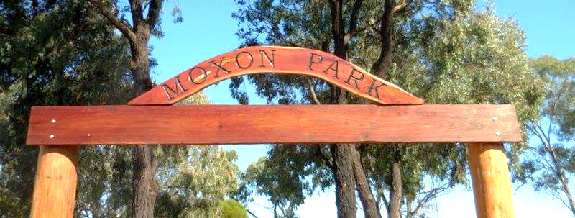
Alfred’s story was featured in the October 2015 edition of this newsletter.

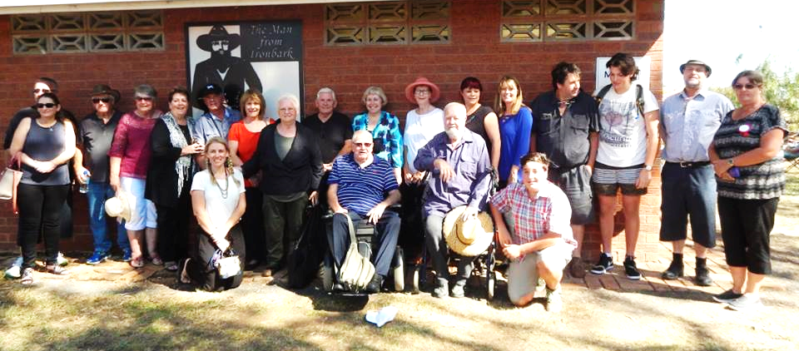
At this year’s “Back to Ironbark” festival (held on Easter Saturday), a shelter shed built on the site of Alfred Moxon’s garage (in Moxon Park) was officially opened by the Mayor of Wellington.
No fewer than 35 Moxons turned up for the event.

One of the organisers of the Festival, Mel Bayliss, arranged special parking for us and organised for all of us to be served lunch in the historic Boehme’s Hall.

Mel Bayliss has a Moxon connection as she is a granddaughter of Alfred’s wife’s (Rachel Carney) sister, Mary Jane Carney.

Mel also escorted us to the cemetery where we were shown Rachel’s grave – sadly without a headstone or other identifying marker.

The Moxon mob got quite a lot of publicity and even featured on local TV and in local newspapers, as well as on local radio.

But the Muster had a particular significance to a couple of our newest Moxon Society members, Pamella and Leith Vernon.

It’s best that your editor allows Pamella to explain in her own words why this day had special meaning for her and her family.

Miriam’s
Miracle
By Pamella Vernon

On Christmas Day 2015, as the excitement of presents and being with family ebbed, I got out my phone and started to play with Facebook.

To my surprise, there was a post by a Douglas Moxon and I wondered if, maybe, he and I were related.

My mother, Miriam, was born a Moxon, but none of my family had ever meet any of her Moxon relatives.

The reasons for this lack of knowledge or contact go back to 1950.

In September of that year, 1950, our beloved mother and wife of Harrington, Miriam Doreen Vernon (nee Moxon) aged 27, languished for four days after giving birth to twins, a boy and a girl, before passing from this life, into the presence of God. Our Dadda, Harrington, suffered a physical and mental breakdown, and unable to care for his young family, he needed to ask for support.

In fact, the decisions that were necessary for him to make at the time were basically taken out of his hands, as the Child Welfare Department deemed he was unfit to care for his five young children and took all children into care.

At this time the baby twins were also taken by the Superintendent of the institution to which we would be sent and his wife and within twelve weeks they had adopted the twins, which was remarkable, because they weren’t made wards of the state.

This appears to have been irregular and later it was established that our father was a victim of forced adoption. He called it “illegal adoption”.

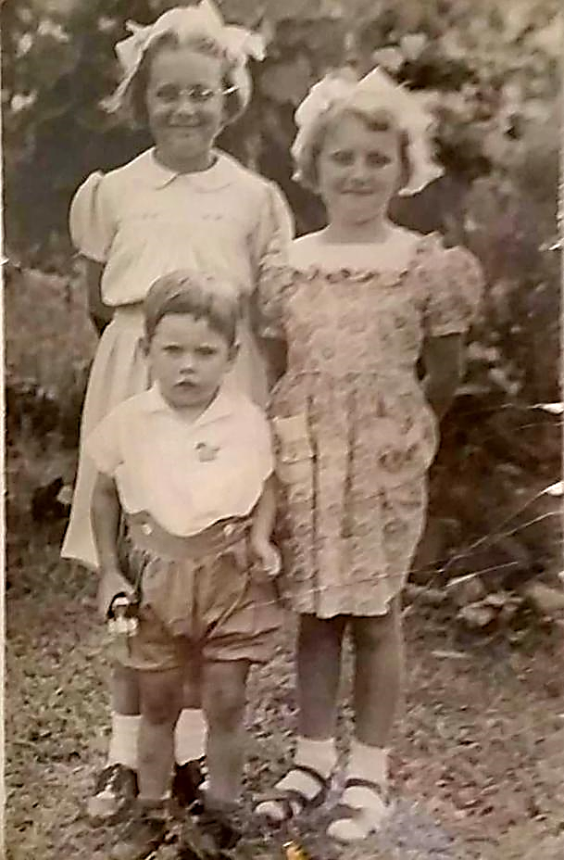
When he was well enough to visit his children, invariably there was trouble, and consequently he was forbidden to visit his children for the rest of his life.

The night we entered that Faith-run Children’s Home, is profoundly imprinted in my mind.

As we children arrived at the Institution, in the huge double doorway stood a woman in a white uniform and white veil, holding a hurricane lantern. She approached the top of the broad stairway and the entrance to the imposing building where there was a tall man moving closely behind her. He was the man who had taken the new baby twins who had survived: our little baby brother and sister - the twins.
Yvonne, Pamella and Leith

Everything from that point on was strangely quick. We found ourselves in the office, our Dadda was gone. My sister Yvonne kept calling out, “where is our little brother Leithy”, please, please, I will take care of him”.

At this point, I was absolutely overwhelmed and frozen with fear and dread, and this was when Yvonne looked at the Superintendent and said “I know who you are, you’re the man who took away our new babies!”.

Her fate was sealed that very moment: the torment, torture and brutality began for her at that instant and never stopped.
Yvonne was clutching the last remaining belongings of our mother, Miriam, in an old Whitman’s chocolate tin box containing our mother’s meagre possessions, that she treasured: a small bottle of ‘Midnight Blue Perfume’ in a purple bottle with a tassel, perming solution, butterfly clips, bobby pins, a cameo pill box, an enamel butterfly broach, rosary beads (we weren’t Catholic, but Miriam loved her rosary beads), all of these possessions were taken one by one by the Superintendent, who studied them and then threw them into a black waste paper basket, with the cold hearted comments…”Ummm, you won’t be needing these things here”.

He then turned to me, as I held my knitted dolly ‘Mrs Gafoopie’. He asked to have a look. He then smelt it, frowned and chucked my precious ‘Mrs Gafoopie’ into the black waste paper basket, again uttering “you won’t be needing that horrible, smelly thing here either”.

That was our horrific and traumatic introduction to the Faith-run Children’s Home - “The love of God, a mere afterthought”. The torment still remains with me today.

Although the twins lived in the same institution we were never allowed to acknow-ledge our relationship.

Until Christmas 2015, we had never had contact with any of my mother’s Moxon family.

So I sent a message to Douglas and quickly received a reply advising me to contact John Bruce Moxon and his wife Margaret Tucker Moxon, who may be able to assist.

John and Margaret invited me to visit their home and then explained my Moxon heritage to me.

But the most exciting piece of news was that my aunt – my mother’s half-sister, was alive and well and wanted to meet me.

Shirley Ellen Moxon Cilia, my mother’s sister! I couldn’t believe it.

Shirley and I have spent much time together, met each other’s children, and we travelled together to Stuart Town to meet even more relatives.
And what a day that was.
Leith, Shirley & Pamella

Leith embraced his Aunty Shirley and proclaimed “I’ve always wanted to be able to hug my mum – but this is the next best thing. Thank you.”

Pamella Vernon
April 2016

Access to The Moxon
Footnote to Pamella’s story.
Miriam Moxon was a daughter of George Jack Moxon, who was a son of George Joshua Moxon, who, in turn, was a son of Joshua Middleton Moxon (MX27).

George Jack Moxon married Kathleen Loader and their two children were Rupert and Miriam (Pamella’s mother).

Later George Jack married Ada Lillian Reynolds, and their only child is Shirley Ellen Moxon Cilia.
Society's Ancestry trees
Moxons Down Under Newsletter is produced for the benefit of the members of the Moxon Society who live in Australia and New Zealand.

Contributions are very welcome. Your editor is very happy to assist with the writing of items.

The Editor is John Bruce Moxon (MX27)
johnmoxon1@gmail.com
0412 539 110

Our Co-ordinator is Margaret Tucker Moxon.
margaret.tucker2153@gmail.com
Phone: 02 9636 7752

Post to:
21/6 Amicitia Cct
Northmead NSW 2152

If any member Down Under would like to view their tree on Ancestry (private tree) please email Margaret at:
webmaster@moxonsociety.org and she will arrange viewing rights.

Convict vital records
Does any member own birth, baptism, marriage or death certificates or transcriptions of such for any Moxon, Moxham, Moxom or variated spelling convicts?
If so, Margaret would love to have a copy – please send by PDF or JPG image.

Margaret is currently enrolled in the University of Tasmania’s new course Diploma of Family History, and having completed two units, is about to commence the unit Convicts. There will be some opportunity to research Moxon/Moxham convicts and Society member certificates could be very helpful.

Note that Margaret has already commenced uploading profiles of various convicts to the website/blog www.moxonsdownunder.blogspot.com.au

Please email Margaret (see below) with attachments. Thank you.

